CLASSIQ-LT TABLET MANUAL BOOT

On rare occasions, usually when the tablet was not shut down properly (e.g. power outage or forced shutdown by the power switch turned it off), the boot process stops at the program selection screen.

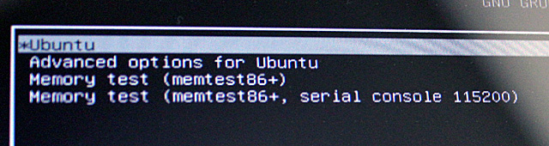

To continue booting, touch the left side of the IntelliQuilter logo, circled on the picture.

